PROGRESS REPORT: 3

Name: Daniel Snider
Project: Topological Characteristics of Web-Based Social Network
Reporting Period: February 8 – February 14

List of Activities

Discussed with Dr. Langlois. Discussion notes:
- Facebook doesn't particularly like crawlers
- Tool given to me is out of date
- Contact Fenwick McKelvey from Infoscape with any questions about Facebook's API

I made a barebones Facebook app and successfully made a connection to it from a python program I wrote on my laptop. My python program uses a library called PyFacebook to make Facebook API calls. So far I've only made basic calls.

I found a blog of an independent researcher in the states who has collected information from 210 million public Facebook profiles (that must be most of them). The researchers name is Pete Warden. The data set includes friend geographic locations, he posted the following picture last week showing connections between people in different US cities:
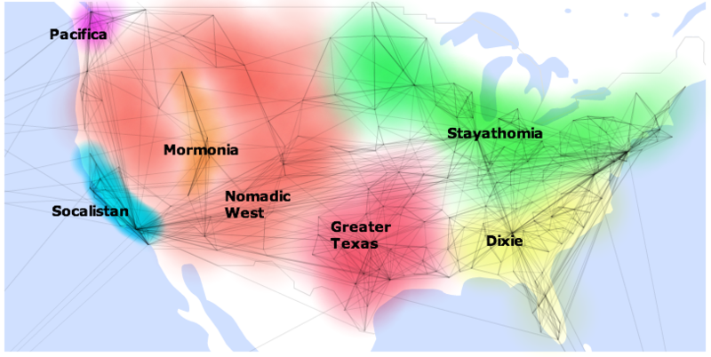

[1]
The data set should include data that could really help us and is recent to within a month. ReadWriteWeb.com alleges that the data set includes partial friends lists[2], which still sounds very promising. Pete Warden's blog post from last week says “If you're a researcher interested in this data set too, do get in touch, I'll be happy to share.”[1]

As of Feb 10th Pete Warden said that “[he] was hoping to get the first release of the academic data set out today, but Facebook have asked for a little more time to check the privacy implications.” This sounds like a good opportunity. Do you agree? Below is a draft message to send him, is it okay?

[draft message begin]
Hello Mr Warden,

You insightful research fascinates me! I'm a research assistant for Dr. Heydari at the University of Ontario Institute of Technology. We are interested in analyzing the topology (who connects to who) of users on Facebook from a mathematical perspective. Our goal is to relate social networks to computer networks. Your data of Facebook friends lists would help us immensely. Would it be possible for us to access it? How is Facebook coming along with their review of the privacy implications?

I look forward to hearing from you,
-Daniel Snider
[draft message end]

List of References I have read

[1] Researcher's blog post:
http://petewarden.typepad.com/searchbrowser/2010/02/how-to-split-up-the-us.html

ReadWriteWeb article on Pete Warden's data:
[2] http://www.readwriteweb.com/archives/facebook_user_data_analysis.php

[3] PyFacebook python library for Facebook calls:
http://wiki.developers.facebook.com/index.php/User:PyFacebook_Tutorial

Current Problems and Obstacles

- The researcher's blog contains many posts that show how difficult a large scale data collection project is. Ranging from many small efficiency things to spending 6 months of crawling.

Plan of action for next reporting period

- Hear back from Shahram on whether to contact the other Poto Warden.
- Further develop Facebook & Blogoshere crawler (if necessary)

